**Ansible Modules**

* **Modules –** There are 100’s of modules available:
  + System
  + Commands
  + Files
  + Database
  + Cloud
  + Windows
  + More
* **System**

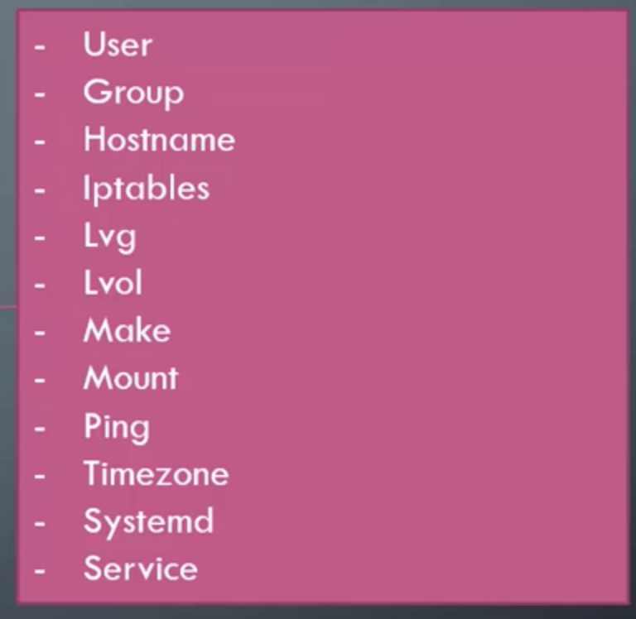

* **Commands**

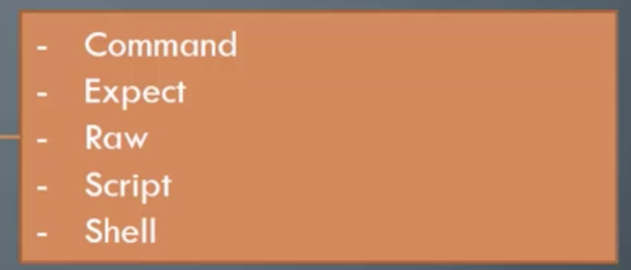

* **Files**

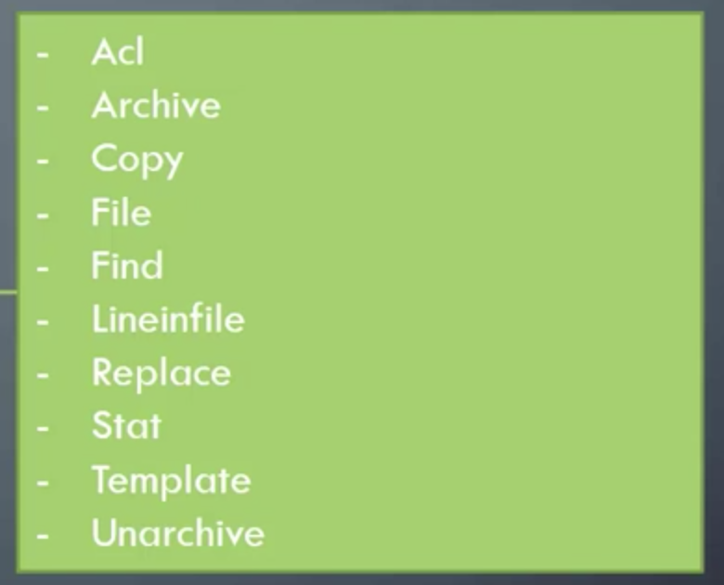

* **Databases**

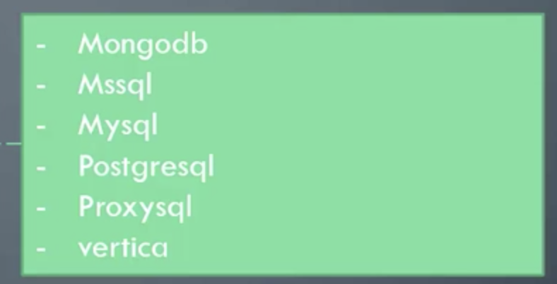

* **Cloud**

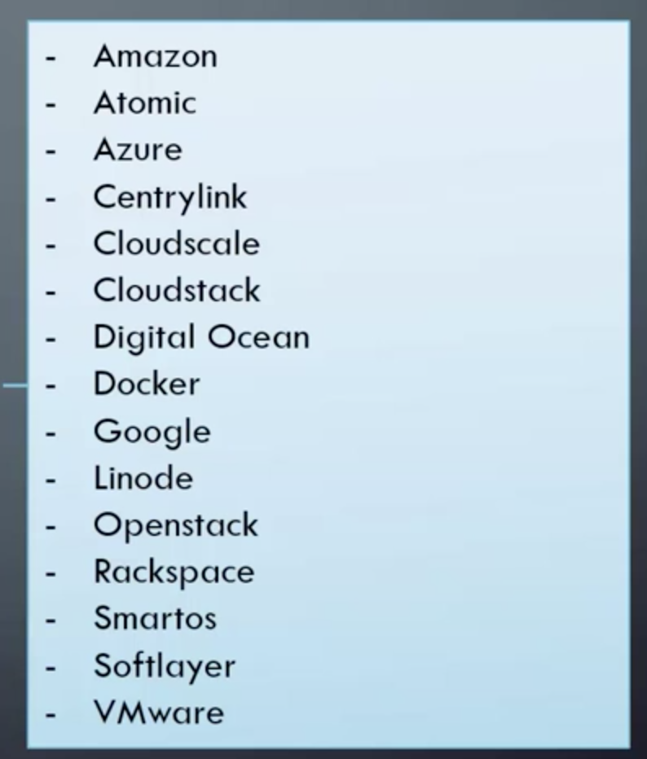

* **Windows**

* **A screenshot of a cell phone

  Description automatically generatedCommands module**: Executes a command on a remote node

Example:

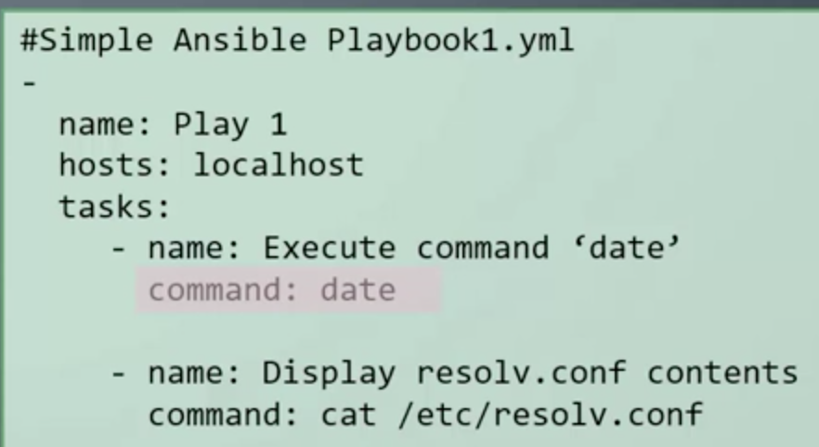

* With ***chdir*** and ***creates***

* A screenshot of a computer

  Description automatically generated**Script module example**
* **A screenshot of a cell phone

  Description automatically generatedService module example**
* **Why started and not start?**

**Idempotency**

An operation is idempotent if the result of performing it once is exactly the same as the result of performing it repeatedly without any intervening actions.

* **LineInFile** Module
  + **A screenshot of a cell phone

    Description automatically generatedWith a script we risk having duplicates if we run the script multiple times**
  + **With Ansible Idempotency, we use Lineinfile to fix this issue**